**System Design Document**

**Retail Store**

**Point of Sale System**

**(Sample System Design Document)**

**David North**

**Table of Contents**

Overview of Solution 6

Technology Solution 11

User Interface 13

Object Model 41

Object Interaction Diagram 42

Algorithms 47

Entity Relationship Diagram 47

External Interface Specifications 48

Class Definitions 51

# Overview of Solution

*This describes the planned solution and how it will meet the functional and non-functional requirements.*

The solution is a desktop point-of-sale system to replace their existing electronic cash registers. This system will maintain all the data require to support the automation of the sales process and provide reporting about the sales activities.

* 1. **System Flow**
     + **Start up**
       1. Import initial data from file
     + **Maintenance Flow**
       1. User Selects from the menu what to maintain
       2. User Selects to add, selects specific item to update or delete
       3. User make changes to the data
       4. User saves the data or cancels the action
     + **Session & Sales Flow**
       1. Cashier selects to starts a session on a register and enters starting cash
       2. Cashier starts a sale
          1. Cashier adds items
          2. Cashier adds payments
       3. Cashier ends sale when all items are entered and all payments
          1. Cashier gives change
          2. Cashier selects to ends sale
       4. Cashier ends session on a register and enters ending cash
       5. System displays if the drawer is out of balance
     + **Reports Flow**
       1. User selects Reports
       2. User selects Report to run
       3. User enters criteria for report
       4. System Generates Report
       5. User views report

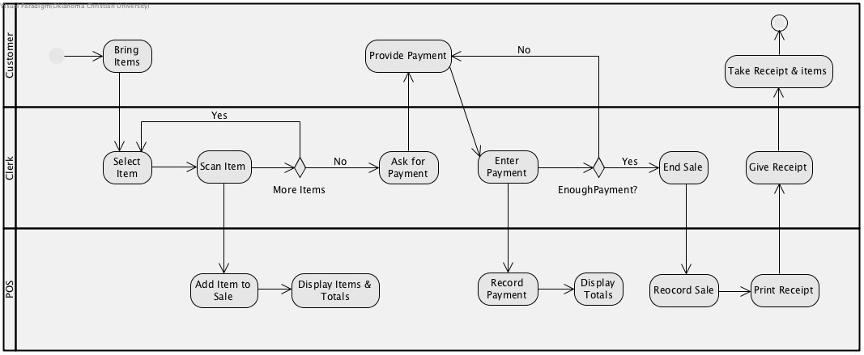

* 1. **System Features that meet the functional requirements specified in** **the Requirements Document.**
* Maintain Item information (add, update, delete)
  + The system provides persistence and UI for adding, updating and deleting items.
* Maintain Tax Rate information (add, update, delete)
* The system provides persistence and UI for adding, updating and deleting tax rates.
* Maintain Cashier information (add, update, delete)
* The system provides persistence and UI for adding, updating and deleting cashiers.
* Maintain Store information (update)
* The system provides persistence and UI for updating store information.
* Maintain Register information (add, delete)
* The system provides persistence and UI for adding and deleting registers.
* Make a sale
* The system provides persistence and UI for making a sale.
* It allows scanning of UPC for adding items to sale.
* It provides automatic sub-totaling, calculation of tax and totaling.
* It provides for persistence and UI for collection of different payment types.
* It provides for authorization of payments.
* Cashier start session on register
* The system provides persistence and UI for starting a session on a register and entering starting cash.
* Cashier end session on register
* The system provides persistence and UI for starting a session on a register and entering starting cash.
* Generate Sales Reports
* System provides reports for the sales for the day by department
* System provides reports for sales for the month by department
* Generate Cashier Reports
* System provides reports for the day by cashier
* System provides reports for the month by cashier
* Generate Item Reports
* System provides reports for the day by item
* System provides reports for the month by item
* Control access to all management functions (maintenance and reports)
* System provides mechanism for maintaining users
* System provides access control to functions based on user
  1. **Design Goals (that meet non-Functional Requirements**
* The system will be easy to use for cashiers.
  + Targets
    - A cashier should be able to enter the sale of 10 items in 90 seconds.
    - A cashier should be able to enter a payment in 30 seconds.
    - A cashier should be able to effectively operate the system with less than one hour of training.
  + Approach
    - The system has been designed to have an easy to use, standard UI.
* The system will be reliable.
  + Target
    - 99.999% availability during store opening hours.
  + Approach
    - The system has been designed to be very reliable using industry standard technology. The system will be tested to minimize defects that would prevent the system form reaching the goal of:
* The system will have a high level of performance.
  + Target
    - All calculations should be performed in under 1 second.
    - All price look-ups should be performed in under 1 second.
  + Approach
    - The system architecture will provide this level of performance.
* The system will be easily supportable.
  + Approach
    - The system uses industry standard technology so it will be able to be support by many technologists.
    - The support team shall offer online and phone support.
    - The company will issue updates to the system four times a year. The updates to the system can be downloaded and install.
* The system will provide interface for payments
  + Approach
    - The system will support a standard interface for 3rd party payment authorization.
* The system will provide good user training.
  + Approach
    - The system will provide a training mode that allows a user to make transactions that are not recorded.
    - The system will provide on screen instructions.
    - The system will have training documentation.
* The system will be operable by non-computer user.
  + Approach
    - The UI is designed to be easy for non-computer users to use and to make it easy to train new users.
* The system will meet all applicable laws.
  + Approach
    - The system does not save credit card numbers but only transmits them to the 3rd party processing service using industry standard protocol.
    - The communications between the system credit card data is over a secure connection.
    - The system provides a mechanism to calculate taxes based on tax rate and tax categories.
  1. **The system design meets the objectives as stated in the requirements**.
     + The system will improve the accuracy of the prices used during check out by scanning the barcodes and looking up the prices in the database.
     + The system will improve the speed of check out by scanning items and automatically looking up the prices.
     + The system will improve the accuracy of the taxes charged during check out by automatically calculating taxes base on the tax rates and the tax category.
     + The system will improve customer satisfaction by taking multiple forms of payment and speeding up the transactions.
     + The system will improve inventory management by reporting what is sold.
     + The system will improve cashier management by reporting what each cashier sold and how well they make change.
     + The system will reduce the labor to put price stickers on each individual items by scanning the preprinted bar codes to determine the prices.

# Technology Solution

*This section describes the technology plan for the solution. This includes the system architecture and technology components.*

The system will have several sub systems.

(component diagram)

../../../../../Desktop/Web%20System%20Comp.jpg

The system will use a single system architecture.

(deployment diagram)

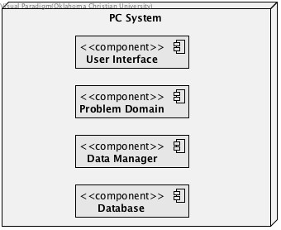

This system will be a single system solution. It has these features:

* Local Database
* GUI Interface
* File import for initialization

This system will use the following technologies:

* Java
* Java Swing UI framework
* Java JPA framwork
* MySQL database
* Run on Windows or MAC

The system is designed to function on a stand alone Windows 10 based PC with 4G of memory and 200 GB hard drive.

# User Interface

*This section describes the menus, screens and reports provided by the system. This includes menu hierarchy diagrams, screen layout wire frames, and report layouts.*

**Main Menu**

Reports

POS

Maintenance

Main

**Maintenance Menu**

Maintenance

Register

Edit

Register

Selection

Cashier

Edit

Cashier

Selection

Price

Edit

UPC

Edit

Item

Edit

Item

Selection

Tax Category

Edit

Tax Category

Selection

Store

Edit

Tax Rate

Edit

**POS Menu**

End Session

Cash Count

Logout

Payment

Entry

Sale

Entry

Login

POS

**Reports Menu**

Cashier

Sales

Report

Item

Sales

Report

Daily Sales

Report

Reports

**Screens**

**Main Screen**

|  |  |
| --- | --- |
| **Screen** | Main |
| **Description** | Displays when application starts and when other pages complete |
| **Fields** | |  |  | | --- | --- | | **Label** | **Field** | | None | store.name | |
| **Actions** | Menu Selection |

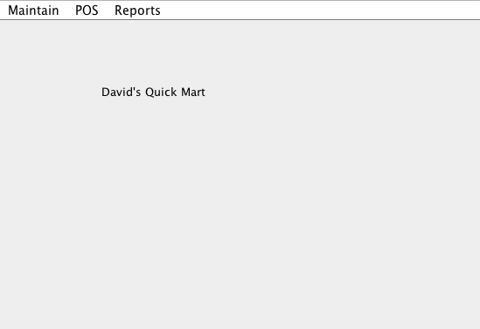

**Store Maintenance**

|  |  |
| --- | --- |
| **Screen** | Store Maintenance |
| **Description** | Allows update of store information |
| **Fields** | |  |  |  | | --- | --- | --- | | **Label** | **Field** | **Validation** | | Name | store.name | Req | |
| **Actions** | **Save** - save the values in the fields and return to Main Screen  **Cancel** - don't save and return to Main Screen |

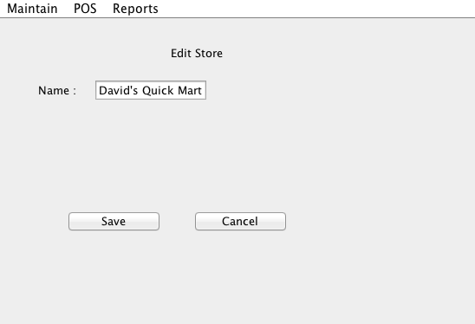

**Tax Category Selection List**

|  |  |
| --- | --- |
| **Screen** | Tax Category Selection List |
| **Description** | Allows adding Tax Category or selecting a Tax Category to update or delete |
| **Selection List** | |  |  |  | | --- | --- | --- | | **Label** | **Field** | **Validation** | | None | taxCatagory.name | none | |
| **Actions** | **Add** - display Tax Category Add Page  **Edit** - display Tax Category Update with selected Tax Category, enable if selected  **Delete** - delete selected Tax Category, enable if selected and ok to Delete |

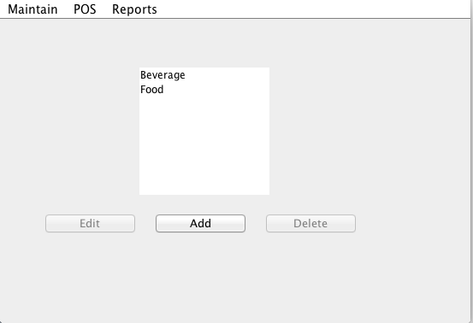

**Tax Category Update**

|  |  |
| --- | --- |
| **Screen** | Tax Category Update |
| **Description** | Updates Tax Category Information |
| **Fields** | |  |  |  | | --- | --- | --- | | **Label** | **Field** | **Validation** | | Category | taxCategory.name | 30, Req | | Tax Rates | taxCategory.rate |  | |
| **Messages** | <Field> is required |
| **Actions** | **Save** - save or add if passes validation and return to Tax Category Selection List  **Cancel** - does not save and returns to Tax Category Selection List |

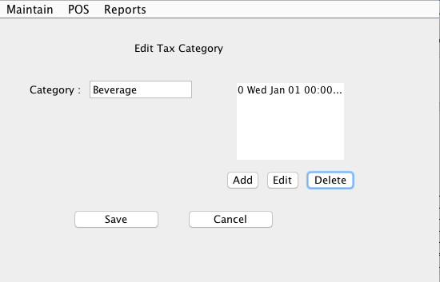

**Tax Rate Update**

|  |  |
| --- | --- |
| **Screen** | Tax Rate Update |
| **Description** | Updates Tax Category Information |
| **Fields** | |  |  |  | | --- | --- | --- | | **Label** | **Field** | **Validation** | | Rate | taxCategory.rate | 99.00, Req | | Date | taxCategory.date | mm/dd/yyyy Req | |
| **Messages** | <Field> is required |
| **Actions** | **Save** - save or add if passes validation and return to Tax Category Update  **Cancel** - does not save and returns to Tax Category Update |

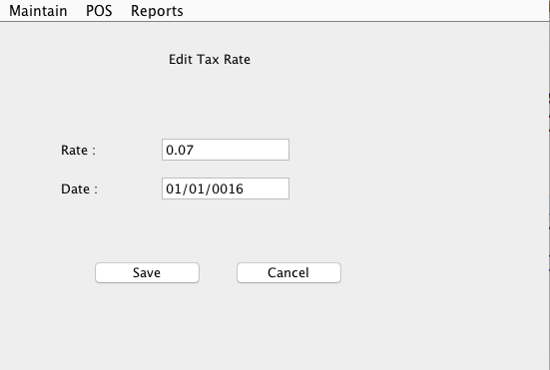

**Item Selection List**

|  |  |
| --- | --- |
| **Screen** | Item Selection List |
| **Description** | Allows adding Item or selecting a Item to update or delete |
| **Selection List** | |  |  |  | | --- | --- | --- | | **Label** | **Field** | **Validation** | | None | item.number | none | | None | item.description | none | | None | item.priceForDate() | none | | None | item.taxRate() | none | |
| **Actions** | **Add** - display Item Add Page  **Edit** - display Item Update with selected Item, enable if selected  **Delete** - delete selected Item, enable if selected and ok to Delete |

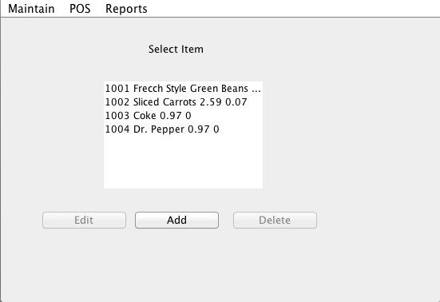

**Item Update**

|  |  |
| --- | --- |
| **Screen** | ItemUpdate |
| **Description** | Updates ItemInformation |
| **Fields** | |  |  |  | | --- | --- | --- | | **Label** | **Field** | **Validation** | | Number | item.number | Req, ######  No dup | | Description | item.description | 50 | | Tax Category | item.taxCategory | list | | UPC Selection | item.upcs |  | | Price Selection | itme.prices |  | |
| **Actions** | **Edit UPC -** display UPC Update with selected UPC, enable if selected  **Add UPC -** display UPC Update  **Delete UPC -** Delete selected UPC, enabled if selected  **Edit Price -** display Price Update with selected Price, enable if selected  **Add Price -** display Price Update,  **Delete Price -** Delete selected Price, enabled if selected and ok to delete  **Save** - save or add if passes validation and return to Item Selection List  **Cancel** - does not save and returns to Item Selection List |

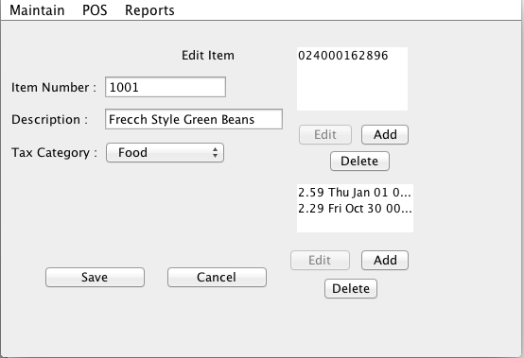

**UPC Update**

|  |  |
| --- | --- |
| **Screen** | UPCUpdate |
| **Description** | Updates UPCInformation |
| **Fields** | |  |  |  | | --- | --- | --- | | **Label** | **Field** | **Validation** | | UPC Code | upc.code | ############ | | Description | item.description | 50 | | Tax Category | item.taxCategory | list | | UPC Selection | item.upcs |  | | Price Selection | itme.prices |  | |
| **Messages** | <Field> is required |
| **Actions** | **Save** - save or add if passes validation and return to Item Update  **Cancel** - does not save and returns to Item Update |

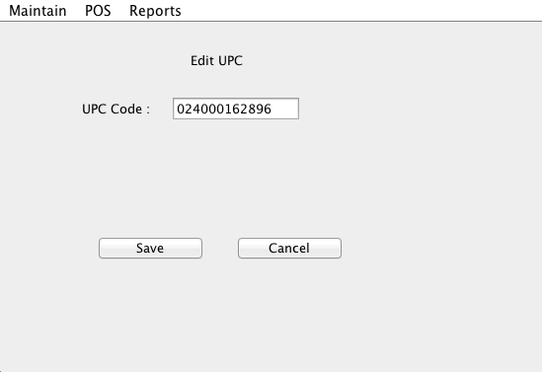

**Price Update**

|  |  |
| --- | --- |
| **Screen** | PriceUpdate |
| **Description** | Updates UPCInformation |
| **Fields** | |  |  |  | | --- | --- | --- | | **Label** | **Field** | **Validation** | | Promo Price | type |  | | Price | price.amout | 999999.99 | | Effective Date | price.effectiveDate | mm/dd/yyyy | | End Date | price.endDate | mm/dd/yyyy | |
| **Messages** | <Field> is required |
| **Actions** | **Promo Price -** change to Price or Promo Price display End date if Promo Price  **Save** - save or add if passes validation and return to Item Update  **Cancel** - does not save and returns to Item Update |

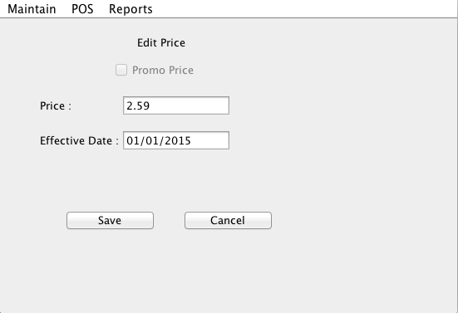

**Cashier Selection List**

|  |  |
| --- | --- |
| **Screen** | Cashier Selection List |
| **Description** | Allows adding Cashier or selecting a Cashier to update or delete |
| **Selection List** | |  |  |  | | --- | --- | --- | | **Label** | **Field** | **Validation** | | None | cashier.number | none | | None | cashier.name | none | |
| **Actions** | Add - display Cashier Add Page  Edit - display Cashier Update with selected Cashier, enable if selected  Delete - delete selected Cashier, enable if selected and ok to Delete |

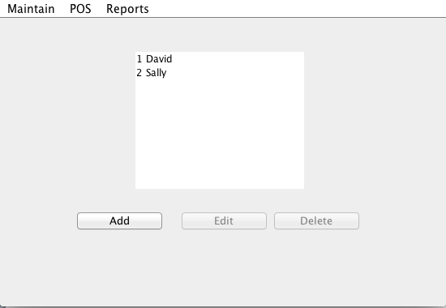

**Cashier Update**

|  |  |
| --- | --- |
| **Screen** | Cashier Update |
| **Description** | Updates Cashier Information |
| **Fields** | |  |  |  | | --- | --- | --- | | **Label** | **Field** | **Validation** | | Number | cashier.number | Req, 999  No dup | | SSN | cashier.ssn | ###-##-#### | | Name | cashier.name | Req | | Address | cashier.name | 30 | | City | cashier.name | 30 | | State | cashier.name | 2 | | Zip | cashier.name | ##### | | Phone | cashier.name | ###-###-#### | |
| **Messages** | <Field> is required  Duplicate Number |
| **Actions** | **Save** - save or add (updates Cashier and Person) if passes validation and return to Cashier Selection List-  **Cancel** - does not save and returns to Cashier Selection List |

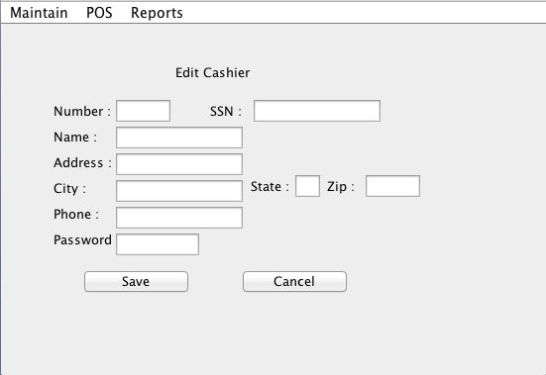

**Register Selection List**

|  |  |
| --- | --- |
| **Screen** | Register Selection List |
| **Description** | Allows adding Register or selecting a Register to update or delete |
| **Selection List** | |  |  |  | | --- | --- | --- | | **Label** | **Field** | **Validation** | | None | register. number | none | |
| **Actions** | **Add** - display Register Update Page  **Edit** - display Cashier Update with selected Cashier, enable if selected  **Delete** - delete selected Cashier, enable if selected and ok to Delete |

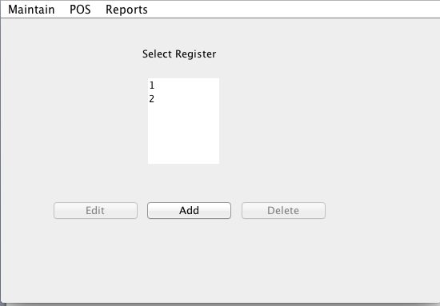

**Register Update**

|  |  |
| --- | --- |
| **Screen** | Register Update |
| **Description** | Updates Register Information |
| **Fields** | |  |  |  | | --- | --- | --- | | **Label** | **Field** | **Validation** | | Number | register.number | Req, 99  No dup | |
| **Messages** | <Field> is required |
| **Actions** | **Save** - save or add if passes validation and return to Register Selection List  **Cancel** - does not save and returns to Register Selection List |

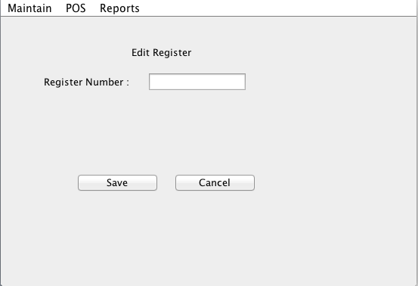

**Start Session**

|  |  |
| --- | --- |
| **Screen** | Start Session |
| **Description** | Starts Session with selected Cashier and Register |
| **Fields** | |  |  |  | | --- | --- | --- | | **Label** | **Field** | **Validation** | | Cashier Number | cashier.number | List | | Register Number | register.number | List | | Starting Casher | session.startingCash | 999999.99 | | Password | cashier.password | must match password for cashier | |
| **Messages** | <Field> is required  Password is invalid |
| **Actions** | **Login** - go to Sale Entry if passes validation  **Cancel** - does not save and returns to Main |

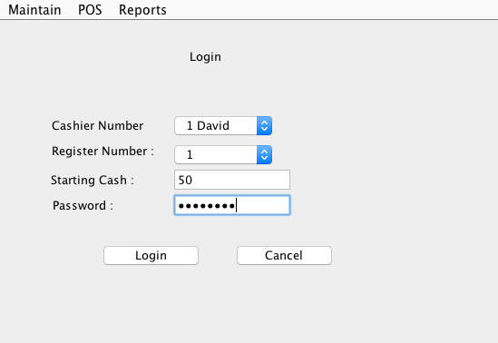

**Sale Entry**

|  |  |
| --- | --- |
| **Screen** | Sale Entry |
| **Description** | Enter data for sale, add items, adds payments. |
| **Fields** | |  |  |  | | --- | --- | --- | | **Label** | **Field** | **Validation** | | Item Number | saleLineItem. item | Look up | | Quantity | saleLineItem.quantity | >0 | | Item List | sale.lineItems |  | | Tax Free | sale.taxFree |  | | SubTotal | sale.subTotal() |  | | Tax | sale.calcTax() |  | | Total | sale.calcTotal() |  | | Amt. Tendered | sale.calcAmtTendered() |  | | Change | sale.calcChange() |  | |
| **Messages** | Item is not found.  <Field> is required. |
| **Actions** | **Payment -** go toAdd Payment  **Complete Sale -** add sale to session if payment => sale total and go to new Sale Entry  **Cancel Sale -** don't add sale to session and go to new Sale Entry  **End Session** - go to End Session |

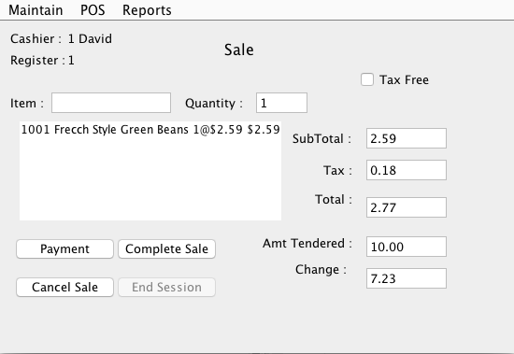

**Payment Entry**

|  |  |
| --- | --- |
| **Screen** | Payment |
| **Description** | Select Payment type to enter |
| **Fields** | |  |  |  | | --- | --- | --- | | **Label** | **Field** | **Validation** | | Payment Due | sale.paymentDue() |  | | Amount Tendered | sale.amountTendered() | >0 | |
| **Actions** | **Cash - display Cash Entry**  **Check - display Check Entry**  **Credit - display Credit Entry**  **Payment Complete -** add payment sale to session, enble if there is a payment  **Cancel -** don't add payment to session and go to new Sale Entry |

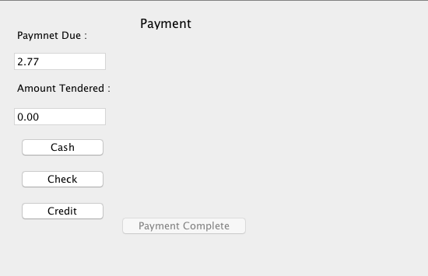

**Cash Payment Entry**

|  |  |
| --- | --- |
| **Screen** | Cash Payment Entry |
| **Description** | Add Cash Payment Entry |
| **Fields** | |  |  |  | | --- | --- | --- | | **Label** | **Field** | **Validation** | | Amount Tendered | payment.amount | >0 | |
| **Messages** | <Field> is required. |
| **Actions** | **Cash -** display Cash Entry  **Check -** display Check Entry  **Credit -** display Credit Entry  **Save** - add payment to sale  **Cancel** - display Payment Entry  **Payment Complete -** add payment sale to session, enable if there is a payment saved |

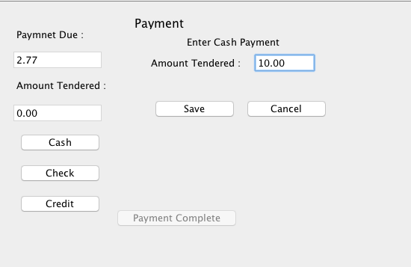

**Check Payment Entry**

|  |  |
| --- | --- |
| **Screen** | Check Payment Entry |
| **Description** | Add Check Payment Entry |
| **Fields** | |  |  |  | | --- | --- | --- | | **Label** | **Field** | **Validation** | | Amount | payment.amount | Req | | Routing Number | check.rountingNumber | Req | | Account Number | check.accountNumber | Req | | Check Number | check.number | Req | |
| **Messages** | <Field> is required. |
| **Actions** | **Cash -** display Cash Entry  **Check -** display Check Entry  **Credit -** display Credit Entry  **Save** - add payment to sale  **Cancel** - display Payment Entry  **Payment Complete -** add payment sale to session, enable if there is a payment saved |

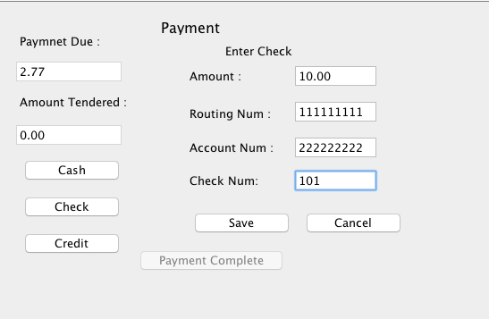

**Credit Payment Entry**

|  |  |
| --- | --- |
| **Screen** | Credit Payment Entry |
| **Description** | Add Credit Payment Entry |
| **Fields** | |  |  |  | | --- | --- | --- | | **Label** | **Field** | **Validation** | | Amount | payment.amount | Req | | Card Type | credit.cardType | List, Req | | Amount Tendered | credit.accountNumber | ################  Req | | Check Number | credit.expireDate | mm/yyyy  Req | |
| **Messages** | <Field> is required. |
| **Actions** | **Cash -** display Cash Entry  **Check -** display Check Entry  **Credit -** display Credit Entry  **Save** - add payment to sale  **Cancel** - display Payment Entry  **Payment Complete -** add payment sale to session, enable if there is a payment saved |

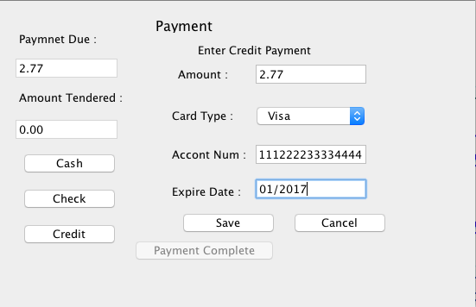

**End Session**

|  |  |
| --- | --- |
| **Screen** | End Session |
| **Description** | End a session and determine if the cash drawer is over or short |
| **Fields** | |  |  |  | | --- | --- | --- | | **Label** | **Field** | **Validation** | | Cashier | session.cashier.number() |  | | Register | session.register.number() |  | | Number of Sales | session.numberSales() |  | | Total Sales | session.totalSales() |  | | Enter Cash | session.endingCash | 9999.99 | | Cash Count Diff: | session.cashDiff() |  | |
| **Messages** | <Field> is required. |
| **Actions** | **End Session** - return to Main |

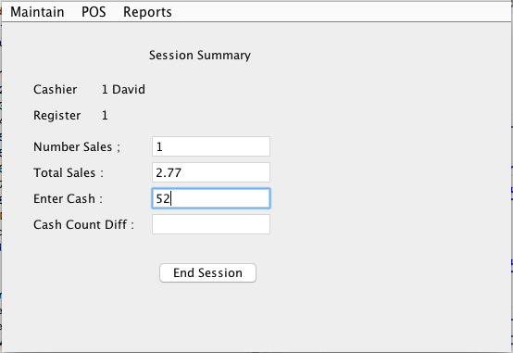

**Cashier Report**

|  |  |
| --- | --- |
| **Screen** | Cashier Report |
| **Description** | Display Cashier Report for Date |
| **Fields** | |  |  |  | | --- | --- | --- | | **Label** | **Field** | **Validation** | | Date |  | mm/dd/yyyy | | Report |  |  | |
| **Messages** | <Field> is required. |
| **Selection** | Cashiers with sales on date entered |
| **Sort** | by cashier number |
| **Grouping** | none |
| **Totaling** | Total Number of Sales, Total Sales, ,Total Amt. Diff. |
| **Report Columns** | Number, Name, Number of Sales, Total Amt. Diff |
| **Actions** | **Generate -** create and display report  **Close -** Return to Main |

**Item Report**

|  |  |
| --- | --- |
| **Screen** | Item Report |
| **Description** | Display Item Report for Date |
| **Fields** | |  |  |  | | --- | --- | --- | | **Label** | **Field** | **Validation** | | Date |  | mm/dd/yyyy | | Report |  |  | |
| **Messages** | <Field> is required. |
| **Selection** | Item with sales on date entered |
| **Sort** | by item number |
| **Grouping** | none |
| **Totaling** | Total Sales, Total Number Items sold , |
| **Report Columns** | Number, Name, Total Sales, Number sold, |
| **Actions** | **Generate -** create and display report  **Close -** Return to Main |

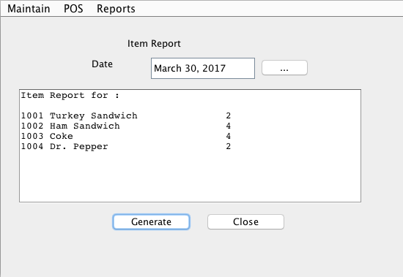

**Daily Sales Report**

|  |  |
| --- | --- |
| **Screen** | Daily Sales |
| **Description** | Display Sales Report for Date |
| **Fields** | |  |  |  | | --- | --- | --- | | **Label** | **Field** | **Validation** | | Date |  | mm/dd/yyyy | | Report |  |  | |
| **Messages** | <Field> is required. |
| **Selection** | Sales on date entered |
| **Sort** | by transaction time |
| **Grouping** | none |
| **Totaling** | Total Cash, Total Check, Total Credit, Total Sales |
| **Report Columns** | Time, Total Cash, Total Check, Total Credit, Total Sales |
| **Actions** | **Generate -** create and display report  **Close -** Return to Main |

# Object Model

*This section is the object model designed for the system.*

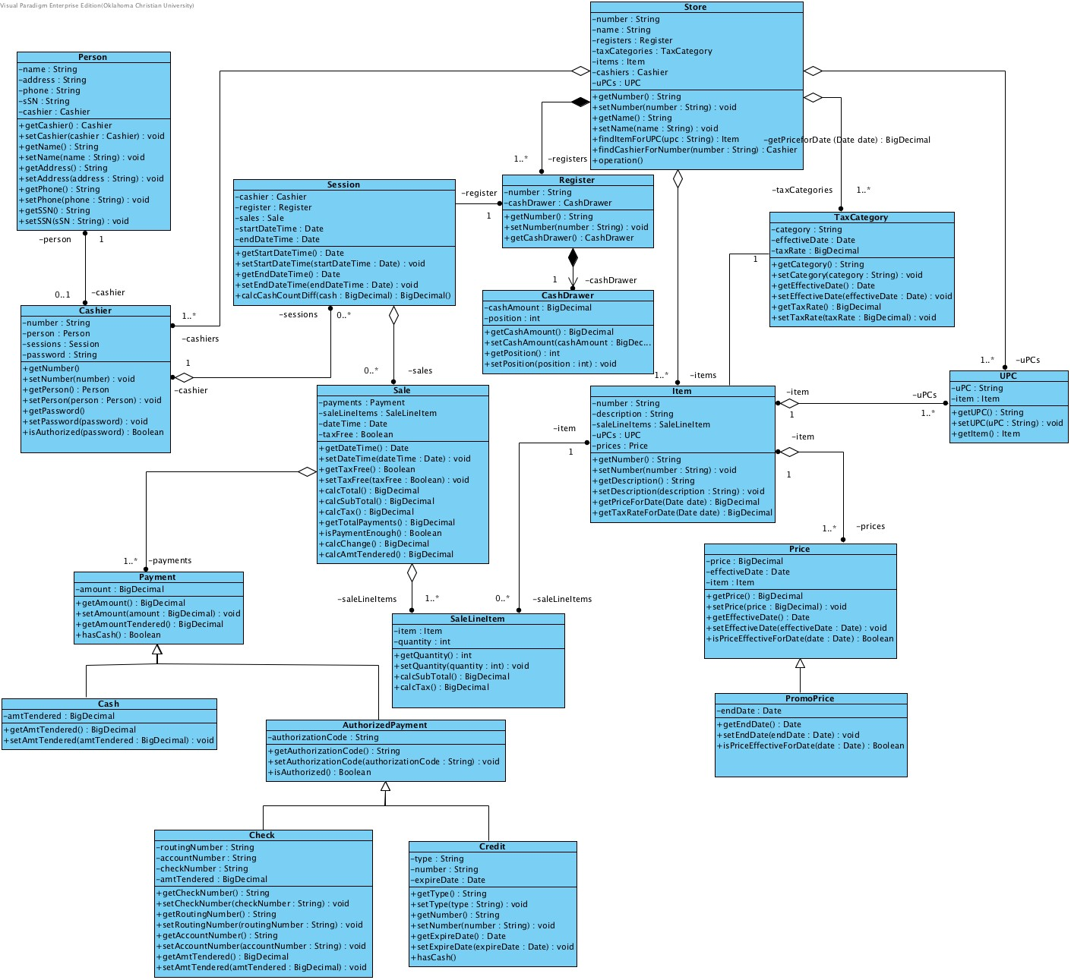

# Object Interaction Diagram

*This section is a set of the object interaction diagrams for the system.*

**Calculate Total -** this interaction is used by the sales UI page to display the total of the sales.

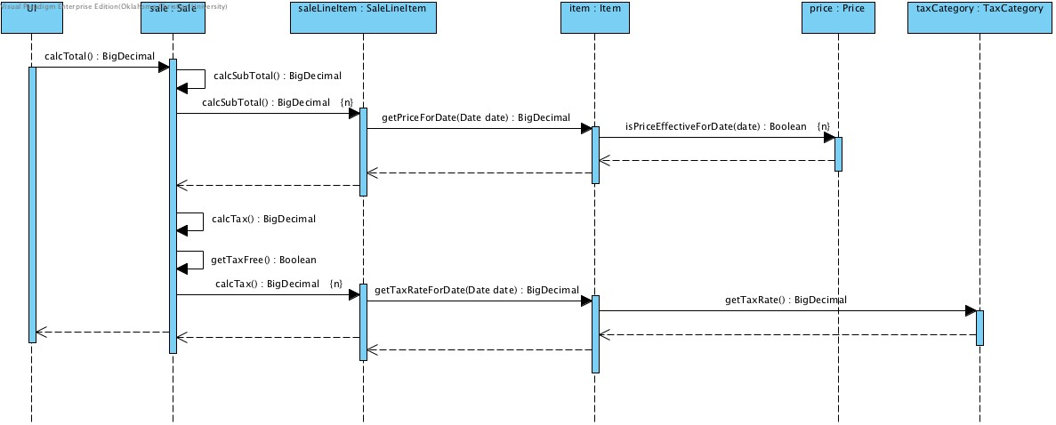

**Is Payment Enough -** this interaction is used by the sales UI page to determine if the payment is enough to allow the sale to end.

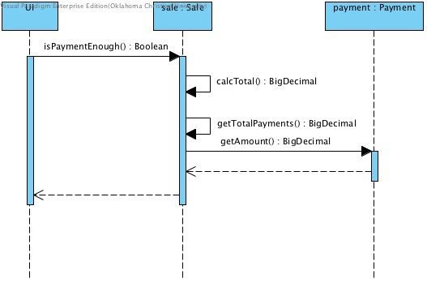

**Calculate Change -** this interaction is used by the sales UI page to determine the amount of change to give.

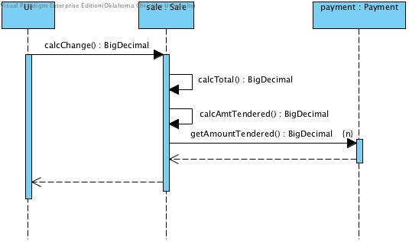

**Calculate Over and Short -** this interaction is used by the sales UI page to determine the amount of difference between actual cash in drawer and expected cash in drawer.

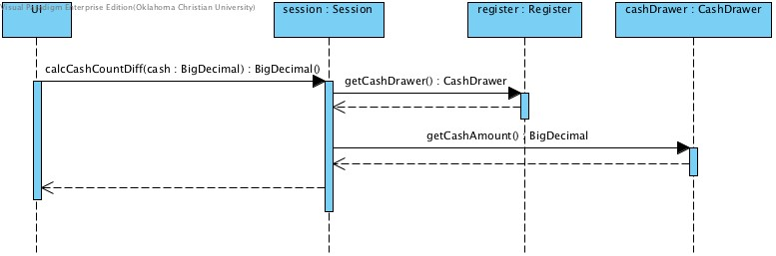

**Calculate Sales for Items -** this interaction is used by the sales UI page to determine the amount of difference between actual cash in drawer and expected cash in drawer.

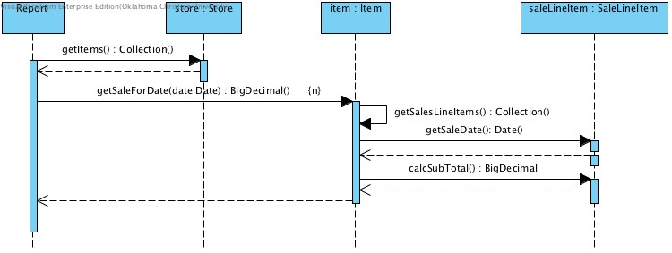

# Algorithms

*This section contains any special algorithms that need to be expressed. They could be expressed in pseudo-code.*

None Required.

# Entity Relationship Diagram

*This section is the ERD for the database design for the system.*

Not Required - No Database being used

# External Interface Specifications

*This section describes in detail the formation and technology for any external interfaces including file interfaces.*

**CSV File Import**

The csv import file contains initial load data for store, items, prices, etc.

Each row is a instance with Class Name, <data fields for Class>. Some classes have rows that represent instances that are related and are to be added to this instances.

Data fields

Store

* Name

Tax Category

* Category
* Rate
* Effective Date

Item

* Number
* Description
* UPC
* Price

Registers

* Number

Cashiers

* Number
* Name
* SSN
* Address
* City
* State
* Zip
* Phone
* Password

Session

* Register Number
* Cashier Number

Sale

* Tax Free

Sale Line Item

* Item Number
* Quantity

Payment

* Type
* Amount
* Amount Tendered
* if Check
  + Routing Number
  + Account Number
  + Check Number
* If Credit
  + Type
  + Number
  + Expiration Date

*Sample Data*

|  |  |  |  |  |  |  |  |  |  |
| --- | --- | --- | --- | --- | --- | --- | --- | --- | --- |
| Store | David's Quick Mart | |  |  |  |  |  |  |  |
| TaxCategory | Food | 0.07 | 1/1/15 |  |  |  |  |  |  |
| TaxCategory | Beverage | 0 | 1/1/15 |  |  |  |  |  |  |
| Cashier | 1 | David | 111-11-1111 | 1 1st Street | Edmond | OK | 73034 | 405.348.1111 | password1 |
| Cashier | 2 | Sally | 222-22-2222 | 2 2nd Street | Edmond | OK | 73034 | 405.348.2222 | password2 |
| Item | 1001 | 24000162896 | Frecch Style Green Beans | Food | 2.59 | 1/1/15 | 2.29 | 10/30/15 | 11/30/15 |
| Item | 1002 | 24000162995 | Sliced Carrots | Food | 2.59 | 1/1/15 |  |  |  |
| Item | 1003 | 33333333333 | Coke | Beverage | 0.97 | 1/1/15 | 0.79 | 9/1/15 | 10/1/15 |
| Item | 1004 | 44444444444 | Dr. Pepper | Beverage | 0.97 | 1/1/15 | 0.79 | 10/30/15 | 11/30/15 |
| Register | 1 |  |  |  |  |  |  |  |  |
| Register | 2 |  |  |  |  |  |  |  |  |
| Session | 1 | 2 |  |  |  |  |  |  |  |
| Sale | Y |  |  |  |  |  |  |  |  |
| SaleLineItem | 1001 | 1 |  |  |  |  |  |  |  |
| SaleLineItem | 1002 | 2 |  |  |  |  |  |  |  |
| Payment | Cash | 7.47 | 10 |  |  |  |  |  |  |
| Sale | N |  |  |  |  |  |  |  |  |
| SaleLineItem | 1003 | 2 |  |  |  |  |  |  |  |
| SaleLineItem | 1004 | 1 |  |  |  |  |  |  |  |
| Payment | Credit | 2.73 | 2.73 | MC | 1.11122E+15 | 10/1/17 |  |  |  |
| Session | 2 | 1 |  |  |  |  |  |  |  |
| Sale | N |  |  |  |  |  |  |  |  |
| SaleLineItem | 1001 | 1 |  |  |  |  |  |  |  |
| SaleLineItem | 1003 | 2 |  |  |  |  |  |  |  |
| Payment | Cash | 4.39 | 5 |  |  |  |  |  |  |
| Sale | N |  |  |  |  |  |  |  |  |
| SaleLineItem | 1002 | 2 |  |  |  |  |  |  |  |
| SaleLineItem | 1004 | 1 |  |  |  |  |  |  |  |
| Payment | Check | 6.51 | 6.51 | 1010101010 | 111111111 | 1001 |  |  |  |
|  |  |  |  |  |  |  |  |  |  |

# Class Definitions

*This section is a description of classes, attributes and services.*

## AuthorizedPayment

An Authorized Payment represents a payment from a customer on a specific sale that needs to be authorized by a 3rd party authorization service

## Properties

|  |  |
| --- | --- |
| Visibility | public |
| Abstract | false |
| Leaf | false |
| Root | false |
| Active | false |

## Attributes Summary

| Name | Description |
| --- | --- |
| authorizationCode |  |

## Operations Summary

| Name | Description |
| --- | --- |
| getAuthorizationCode |  |
| isAuthorized |  |
| setAuthorizationCode |  |

## Attributes

### authorizationCode

|  |  |
| --- | --- |
| Visibility | private |
| Type | String |

## Operations

### getAuthorizationCode

|  |  |
| --- | --- |
| Visibility | public |
| Return Type | String |

### isAuthorized

|  |  |
| --- | --- |
| Visibility | public |
| Return Type | Boolean |

### setAuthorizationCode

|  |  |
| --- | --- |
| Visibility | public |
| Return Type | void |

## Relationships

| Relationship | From | To |
| --- | --- | --- |
| unnamed | Payment | AuthorizedPayment |
| unnamed | AuthorizedPayment | Check |
| unnamed | AuthorizedPayment | Credit |

## Cash

## Properties

|  |  |
| --- | --- |
| Visibility | public |
| Abstract | false |
| Leaf | false |
| Root | false |
| Active | false |

## Attributes Summary

| Name | Description |
| --- | --- |
| amtTendered |  |

## Operations Summary

| Name | Description |
| --- | --- |
| getAmtTendered |  |
| setAmtTendered |  |

## Attributes

### amtTendered

|  |  |
| --- | --- |
| Visibility | private |
| Type | BigDecimal |

## Operations

### getAmtTendered

|  |  |
| --- | --- |
| Visibility | public |
| Return Type | BigDecimal |

### setAmtTendered

|  |  |
| --- | --- |
| Visibility | public |
| Return Type | void |

## Relationships

| Relationship | From | To |
| --- | --- | --- |
| unnamed | Payment | Cash |

## CashDrawer

## Properties

|  |  |
| --- | --- |
| Visibility | public |
| Abstract | false |
| Leaf | false |
| Root | false |
| Active | false |

## Attributes Summary

| Name | Description |
| --- | --- |
| cashAmount |  |
| position |  |

## Operations Summary

| Name | Description |
| --- | --- |
| getCashAmount |  |
| getPosition |  |
| setCashAmount |  |
| setPosition |  |

## Attributes

### cashAmount

|  |  |
| --- | --- |
| Visibility | private |
| Type | BigDecimal |

### position

|  |  |
| --- | --- |
| Visibility | private |
| Type | int |

## Operations

### getCashAmount

|  |  |
| --- | --- |
| Visibility | public |
| Return Type | BigDecimal |

### getPosition

|  |  |
| --- | --- |
| Visibility | public |
| Return Type | int |

### setCashAmount

|  |  |
| --- | --- |
| Visibility | public |
| Return Type | void |

### setPosition

|  |  |
| --- | --- |
| Visibility | public |
| Return Type | void |

## Relationships

| Relationship | From | To |
| --- | --- | --- |
| unnamed | Register | CashDrawer |

## Traceability

| Type | Value |
| --- | --- |
| Transit To | Calc Cash Over and Short.cashDrawer |

## Cashier

## Properties

|  |  |
| --- | --- |
| Visibility | public |
| Abstract | false |
| Leaf | false |
| Root | false |
| Active | false |

## Attributes Summary

| Name | Description |
| --- | --- |
| number |  |
| password |  |
| person |  |
| sessions |  |

## Operations Summary

| Name | Description |
| --- | --- |
| getNumber |  |
| getPassword |  |
| getPerson |  |
| isAuthorized |  |
| setNumber |  |
| setPassword |  |
| setPerson |  |

## Attributes

### number

|  |  |
| --- | --- |
| Visibility | private |
| Type | String |

### password

|  |  |
| --- | --- |
| Visibility | private |
| Type | String |

### person

|  |  |
| --- | --- |
| Visibility | private |
| Type | Person |

### sessions

|  |  |
| --- | --- |
| Visibility | private |
| Type | Session |

## Operations

### getNumber

|  |  |
| --- | --- |
| Visibility | public |

### getPassword

|  |  |
| --- | --- |
| Visibility | public |

### getPerson

|  |  |
| --- | --- |
| Visibility | public |
| Return Type | Person |

### isAuthorized

|  |  |
| --- | --- |
| Visibility | public |
| Return Type | Boolean |

### setNumber

|  |  |
| --- | --- |
| Visibility | public |
| Return Type | void |

### setPassword

|  |  |
| --- | --- |
| Visibility | public |
| Return Type | void |

### setPerson

|  |  |
| --- | --- |
| Visibility | public |
| Return Type | void |

## Relationships

| Relationship | From | To |
| --- | --- | --- |
| unnamed | Store | Cashier |
| unnamed | Person | Cashier |
| unnamed | Cashier | Session |

## Check

## Properties

|  |  |
| --- | --- |
| Visibility | public |
| Abstract | false |
| Leaf | false |
| Root | false |
| Active | false |

## Attributes Summary

| Name | Description |
| --- | --- |
| accountNumber |  |
| amtTendered |  |
| checkNumber |  |
| routingNumber |  |

## Operations Summary

| Name | Description |
| --- | --- |
| getAccountNumber |  |
| getAmtTendered |  |
| getCheckNumber |  |
| getRoutingNumber |  |
| setAccountNumber |  |
| setAmtTendered |  |
| setCheckNumber |  |
| setRoutingNumber |  |

## Attributes

### accountNumber

|  |  |
| --- | --- |
| Visibility | private |
| Type | String |

### amtTendered

|  |  |
| --- | --- |
| Visibility | private |
| Type | BigDecimal |

### checkNumber

|  |  |
| --- | --- |
| Visibility | private |
| Type | String |

### routingNumber

|  |  |
| --- | --- |
| Visibility | private |
| Type | String |

## Operations

### getAccountNumber

|  |  |
| --- | --- |
| Visibility | public |
| Return Type | String |

### getAmtTendered

|  |  |
| --- | --- |
| Visibility | public |
| Return Type | BigDecimal |

### getCheckNumber

|  |  |
| --- | --- |
| Visibility | public |
| Return Type | String |

### getRoutingNumber

|  |  |
| --- | --- |
| Visibility | public |
| Return Type | String |

### setAccountNumber

|  |  |
| --- | --- |
| Visibility | public |
| Return Type | void |

### setAmtTendered

|  |  |
| --- | --- |
| Visibility | public |
| Return Type | void |

### setCheckNumber

|  |  |
| --- | --- |
| Visibility | public |
| Return Type | void |

### setRoutingNumber

|  |  |
| --- | --- |
| Visibility | public |
| Return Type | void |

## Relationships

| Relationship | From | To |
| --- | --- | --- |
| unnamed | AuthorizedPayment | Check |

## Credit

## Properties

|  |  |
| --- | --- |
| Visibility | public |
| Abstract | false |
| Leaf | false |
| Root | false |
| Active | false |

## Attributes Summary

| Name | Description |
| --- | --- |
| expireDate |  |
| number |  |
| type |  |

## Operations Summary

| Name | Description |
| --- | --- |
| getExpireDate |  |
| getNumber |  |
| getType |  |
| hasCash |  |
| setExpireDate |  |
| setNumber |  |
| setType |  |

## Attributes

### expireDate

|  |  |
| --- | --- |
| Visibility | private |
| Type | Date |

### number

|  |  |
| --- | --- |
| Visibility | private |
| Type | String |

### type

|  |  |
| --- | --- |
| Visibility | private |
| Type | String |

## Operations

### getExpireDate

|  |  |
| --- | --- |
| Visibility | public |
| Return Type | Date |

### getNumber

|  |  |
| --- | --- |
| Visibility | public |
| Return Type | String |

### getType

|  |  |
| --- | --- |
| Visibility | public |
| Return Type | String |

### hasCash

|  |  |
| --- | --- |
| Visibility | public |

### setExpireDate

|  |  |
| --- | --- |
| Visibility | public |
| Return Type | void |

### setNumber

|  |  |
| --- | --- |
| Visibility | public |
| Return Type | void |

### setType

|  |  |
| --- | --- |
| Visibility | public |
| Return Type | void |

## Relationships

| Relationship | From | To |
| --- | --- | --- |
| unnamed | AuthorizedPayment | Credit |

## Item

## Properties

|  |  |
| --- | --- |
| Visibility | public |
| Abstract | false |
| Leaf | false |
| Root | false |
| Active | false |

## Attributes Summary

| Name | Description |
| --- | --- |
| description |  |
| number |  |
| prices |  |
| saleLineItems |  |
| uPCs |  |

## Operations Summary

| Name | Description |
| --- | --- |
| getDescription |  |
| getNumber |  |
| getPriceForDate |  |
| getSaleForDate(date Date) : BigDecimal |  |
| getSalesLineItems() : Collection |  |
| getTaxRateForDate |  |
| setDescription |  |
| setNumber |  |

## Attributes

### description

|  |  |
| --- | --- |
| Visibility | private |
| Type | String |

### number

|  |  |
| --- | --- |
| Visibility | private |
| Type | String |

### prices

|  |  |
| --- | --- |
| Visibility | private |
| Type | Price |

### saleLineItems

|  |  |
| --- | --- |
| Visibility | private |
| Type | SaleLineItem |

### uPCs

|  |  |
| --- | --- |
| Visibility | private |
| Type | UPC |

## Operations

### getDescription

|  |  |
| --- | --- |
| Visibility | public |
| Return Type | String |

### getNumber

|  |  |
| --- | --- |
| Visibility | public |
| Return Type | String |

### getPriceForDate

|  |  |
| --- | --- |
| Visibility | public |
| Return Type | BigDecimal |

### getSaleForDate(date Date) : BigDecimal

|  |  |
| --- | --- |
| Visibility | public |

### getSalesLineItems() : Collection

|  |  |
| --- | --- |
| Visibility | public |

### getTaxRateForDate

|  |  |
| --- | --- |
| Visibility | public |
| Return Type | BigDecimal |

### setDescription

|  |  |
| --- | --- |
| Visibility | public |
| Return Type | void |

### setNumber

|  |  |
| --- | --- |
| Visibility | public |
| Return Type | void |

## Relationships

| Relationship | From | To |
| --- | --- | --- |
| unnamed | SaleLineItem | Item |
| unnamed | TaxCategory | Item |
| unnamed | Store | Item |
| unnamed | Item | Price |
| unnamed | Item | UPC |

## Traceability

| Type | Value |
| --- | --- |
| Transit To | Calculate Total.item |
| Transit To | Sales for Item.item |

## Payment

## Properties

|  |  |
| --- | --- |
| Visibility | public |
| Abstract | false |
| Leaf | false |
| Root | false |
| Active | false |

## Attributes Summary

| Name | Description |
| --- | --- |
| amount |  |

## Operations Summary

| Name | Description |
| --- | --- |
| getAmount |  |
| getAmountTendered |  |
| hasCash |  |
| setAmount |  |

## Attributes

### amount

|  |  |
| --- | --- |
| Visibility | private |
| Type | BigDecimal |

## Operations

### getAmount

|  |  |
| --- | --- |
| Visibility | public |
| Return Type | BigDecimal |

### getAmountTendered

|  |  |
| --- | --- |
| Visibility | public |
| Return Type | BigDecimal |

### hasCash

|  |  |
| --- | --- |
| Visibility | public |
| Return Type | Boolean |

### setAmount

|  |  |
| --- | --- |
| Visibility | public |
| Return Type | void |

## Relationships

| Relationship | From | To |
| --- | --- | --- |
| unnamed | Payment | AuthorizedPayment |
| unnamed | Payment | Cash |
| unnamed | Sale | Payment |

## Traceability

| Type | Value |
| --- | --- |
| Transit To | Is Payment Enough.payment |
| Transit To | Calculate Change.payment |

## Person

## Properties

|  |  |
| --- | --- |
| Visibility | public |
| Abstract | false |
| Leaf | false |
| Root | false |
| Active | false |

## Attributes Summary

| Name | Description |
| --- | --- |
| address |  |
| cashier |  |
| name |  |
| phone |  |
| sSN |  |

## Operations Summary

| Name | Description |
| --- | --- |
| getAddress |  |
| getCashier |  |
| getName |  |
| getPhone |  |
| getSSN |  |
| setAddress |  |
| setCashier |  |
| setName |  |
| setPhone |  |
| setSSN |  |

## Attributes

### address

|  |  |
| --- | --- |
| Visibility | private |
| Type | String |

### cashier

|  |  |
| --- | --- |
| Visibility | private |
| Type | Cashier |

### name

|  |  |
| --- | --- |
| Visibility | private |
| Type | String |

### phone

|  |  |
| --- | --- |
| Visibility | private |
| Type | String |

### sSN

|  |  |
| --- | --- |
| Visibility | private |
| Type | String |

## Operations

### getAddress

|  |  |
| --- | --- |
| Visibility | public |
| Return Type | String |

### getCashier

|  |  |
| --- | --- |
| Visibility | public |
| Return Type | Cashier |

### getName

|  |  |
| --- | --- |
| Visibility | public |
| Return Type | String |

### getPhone

|  |  |
| --- | --- |
| Visibility | public |
| Return Type | String |

### getSSN

|  |  |
| --- | --- |
| Visibility | public |
| Return Type | String |

### setAddress

|  |  |
| --- | --- |
| Visibility | public |
| Return Type | void |

### setCashier

|  |  |
| --- | --- |
| Visibility | public |
| Return Type | void |

### setName

|  |  |
| --- | --- |
| Visibility | public |
| Return Type | void |

### setPhone

|  |  |
| --- | --- |
| Visibility | public |
| Return Type | void |

### setSSN

|  |  |
| --- | --- |
| Visibility | public |
| Return Type | void |

## Relationships

| Relationship | From | To |
| --- | --- | --- |
| unnamed | Person | Cashier |

## Price

## Properties

|  |  |
| --- | --- |
| Visibility | public |
| Abstract | false |
| Leaf | false |
| Root | false |
| Active | false |

## Attributes Summary

| Name | Description |
| --- | --- |
| effectiveDate |  |
| item |  |
| price |  |

## Operations Summary

| Name | Description |
| --- | --- |
| getEffectiveDate |  |
| getPrice |  |
| isPriceEffectiveForDate |  |
| setEffectiveDate |  |
| setPrice |  |

## Attributes

### effectiveDate

|  |  |
| --- | --- |
| Visibility | private |
| Type | Date |

### item

|  |  |
| --- | --- |
| Visibility | private |
| Type | Item |

### price

|  |  |
| --- | --- |
| Visibility | private |
| Type | BigDecimal |

## Operations

### getEffectiveDate

|  |  |
| --- | --- |
| Visibility | public |
| Return Type | Date |

### getPrice

|  |  |
| --- | --- |
| Visibility | public |
| Return Type | BigDecimal |

### isPriceEffectiveForDate

|  |  |
| --- | --- |
| Visibility | public |
| Return Type | Boolean |

### setEffectiveDate

|  |  |
| --- | --- |
| Visibility | public |
| Return Type | void |

### setPrice

|  |  |
| --- | --- |
| Visibility | public |
| Return Type | void |

## Relationships

| Relationship | From | To |
| --- | --- | --- |
| unnamed | Price | PromoPrice |
| unnamed | Item | Price |

## Traceability

| Type | Value |
| --- | --- |
| Transit To | Calculate Total.price |

## PromoPrice

## Properties

|  |  |
| --- | --- |
| Visibility | public |
| Abstract | false |
| Leaf | false |
| Root | false |
| Active | false |

## Attributes Summary

| Name | Description |
| --- | --- |
| endDate |  |

## Operations Summary

| Name | Description |
| --- | --- |
| getEndDate |  |
| isPriceEffectiveForDate |  |
| setEndDate |  |

## Attributes

### endDate

|  |  |
| --- | --- |
| Visibility | private |
| Type | Date |

## Operations

### getEndDate

|  |  |
| --- | --- |
| Visibility | public |
| Return Type | Date |

### isPriceEffectiveForDate

|  |  |
| --- | --- |
| Visibility | public |
| Return Type | Boolean |

### setEndDate

|  |  |
| --- | --- |
| Visibility | public |
| Return Type | void |

## Relationships

| Relationship | From | To |
| --- | --- | --- |
| unnamed | Price | PromoPrice |

## Register

## Properties

|  |  |
| --- | --- |
| Visibility | public |
| Abstract | false |
| Leaf | false |
| Root | false |
| Active | false |

## Attributes Summary

| Name | Description |
| --- | --- |
| cashDrawer |  |
| number |  |

## Operations Summary

| Name | Description |
| --- | --- |
| getCashDrawer |  |
| getNumber |  |
| setNumber |  |

## Attributes

### cashDrawer

|  |  |
| --- | --- |
| Visibility | private |
| Type | CashDrawer |

### number

|  |  |
| --- | --- |
| Visibility | private |
| Type | String |

## Operations

### getCashDrawer

|  |  |
| --- | --- |
| Visibility | public |
| Return Type | CashDrawer |

### getNumber

|  |  |
| --- | --- |
| Visibility | public |
| Return Type | String |

### setNumber

|  |  |
| --- | --- |
| Visibility | public |
| Return Type | void |

## Relationships

| Relationship | From | To |
| --- | --- | --- |
| unnamed | Store | Register |
| unnamed | Session | Register |
| unnamed | Register | CashDrawer |

## Traceability

| Type | Value |
| --- | --- |
| Transit To | Calc Cash Over and Short.register |

## Sale

## Properties

|  |  |
| --- | --- |
| Visibility | public |
| Abstract | false |
| Leaf | false |
| Root | false |
| Active | false |

## Attributes Summary

| Name | Description |
| --- | --- |
| dateTime |  |
| payments |  |
| saleLineItems |  |
| taxFree |  |

## Operations Summary

| Name | Description |
| --- | --- |
| calcAmtTendered |  |
| calcChange |  |
| calcSubTotal |  |
| calcTax |  |
| calcTotal |  |
| getDateTime |  |
| getTaxFree |  |
| getTotalPayments |  |
| isPaymentEnough |  |
| setDateTime |  |
| setTaxFree |  |

## Attributes

### dateTime

|  |  |
| --- | --- |
| Visibility | private |
| Type | Date |

### payments

|  |  |
| --- | --- |
| Visibility | private |
| Type | Payment |

### saleLineItems

|  |  |
| --- | --- |
| Visibility | private |
| Type | SaleLineItem |

### taxFree

|  |  |
| --- | --- |
| Visibility | private |
| Type | Boolean |

## Operations

### calcAmtTendered

|  |  |
| --- | --- |
| Visibility | public |
| Return Type | BigDecimal |

### calcChange

|  |  |
| --- | --- |
| Visibility | public |
| Return Type | BigDecimal |

### calcSubTotal

|  |  |
| --- | --- |
| Visibility | public |
| Return Type | BigDecimal |

### calcTax

|  |  |
| --- | --- |
| Visibility | public |
| Return Type | BigDecimal |

### calcTotal

|  |  |
| --- | --- |
| Visibility | public |
| Return Type | BigDecimal |

### getDateTime

|  |  |
| --- | --- |
| Visibility | public |
| Return Type | Date |

### getTaxFree

|  |  |
| --- | --- |
| Visibility | public |
| Return Type | Boolean |

### getTotalPayments

|  |  |
| --- | --- |
| Visibility | public |
| Return Type | BigDecimal |

### isPaymentEnough

|  |  |
| --- | --- |
| Visibility | public |
| Return Type | Boolean |

### setDateTime

|  |  |
| --- | --- |
| Visibility | public |
| Return Type | void |

### setTaxFree

|  |  |
| --- | --- |
| Visibility | public |
| Return Type | void |

## Relationships

| Relationship | From | To |
| --- | --- | --- |
| unnamed | Session | Sale |
| unnamed | Sale | Payment |
| unnamed | Sale | SaleLineItem |

## Traceability

| Type | Value |
| --- | --- |
| Transit To | Calculate Total.sale |
| Transit To | Is Payment Enough.sale |
| Transit To | Calculate Change.sale |

## SaleLineItem

## Properties

|  |  |
| --- | --- |
| Visibility | public |
| Abstract | false |
| Leaf | false |
| Root | false |
| Active | false |

## Attributes Summary

| Name | Description |
| --- | --- |
| item |  |
| quantity |  |

## Operations Summary

| Name | Description |
| --- | --- |
| calcSubTotal |  |
| calcTax |  |
| getQuantity |  |
| getSaleDate(): Date |  |
| setQuantity |  |

## Attributes

### item

|  |  |
| --- | --- |
| Visibility | private |
| Type | Item |

### quantity

|  |  |
| --- | --- |
| Visibility | private |
| Type | int |

## Operations

### calcSubTotal

|  |  |
| --- | --- |
| Visibility | public |
| Return Type | BigDecimal |

### calcTax

|  |  |
| --- | --- |
| Visibility | public |
| Return Type | BigDecimal |

### getQuantity

|  |  |
| --- | --- |
| Visibility | public |
| Return Type | int |

### getSaleDate(): Date

|  |  |
| --- | --- |
| Visibility | public |

### setQuantity

|  |  |
| --- | --- |
| Visibility | public |
| Return Type | void |

## Relationships

| Relationship | From | To |
| --- | --- | --- |
| unnamed | Sale | SaleLineItem |
| unnamed | SaleLineItem | Item |

## Traceability

| Type | Value |
| --- | --- |
| Transit To | Calculate Total.saleLineItem |
| Transit To | Sales for Item.saleLineItem |

## Session

## Properties

|  |  |
| --- | --- |
| Visibility | public |
| Abstract | false |
| Leaf | false |
| Root | false |
| Active | false |

## Attributes Summary

| Name | Description |
| --- | --- |
| cashier |  |
| endDateTime |  |
| register |  |
| sales |  |
| startDateTime |  |

## Operations Summary

| Name | Description |
| --- | --- |
| calcCashCountDiff |  |
| getEndDateTime |  |
| getStartDateTime |  |
| setEndDateTime |  |
| setStartDateTime |  |

## Attributes

### cashier

|  |  |
| --- | --- |
| Visibility | private |
| Type | Cashier |

### endDateTime

|  |  |
| --- | --- |
| Visibility | private |
| Type | Date |

### register

|  |  |
| --- | --- |
| Visibility | private |
| Type | Register |

### sales

|  |  |
| --- | --- |
| Visibility | private |
| Type | Sale |

### startDateTime

|  |  |
| --- | --- |
| Visibility | private |
| Type | Date |

## Operations

### calcCashCountDiff

|  |  |
| --- | --- |
| Visibility | public |
| Return Type | BigDecimal() |

### getEndDateTime

|  |  |
| --- | --- |
| Visibility | public |
| Return Type | Date |

### getStartDateTime

|  |  |
| --- | --- |
| Visibility | public |
| Return Type | Date |

### setEndDateTime

|  |  |
| --- | --- |
| Visibility | public |
| Return Type | void |

### setStartDateTime

|  |  |
| --- | --- |
| Visibility | public |
| Return Type | void |

## Relationships

| Relationship | From | To |
| --- | --- | --- |
| unnamed | Cashier | Session |
| unnamed | Session | Sale |
| unnamed | Session | Register |

## Traceability

| Type | Value |
| --- | --- |
| Transit To | Calc Cash Over and Short.session |

## Store

## Properties

|  |  |
| --- | --- |
| Visibility | public |
| Abstract | false |
| Leaf | false |
| Root | false |
| Active | false |

## Attributes Summary

| Name | Description |
| --- | --- |
| cashiers |  |
| items |  |
| name |  |
| number |  |
| registers |  |
| taxCategories |  |
| uPCs |  |

## Operations Summary

| Name | Description |
| --- | --- |
| findCashierForNumber |  |
| findItemForUPC |  |
| getItems() : Collection |  |
| getName |  |
| getNumber |  |
| operation |  |
| setName |  |
| setNumber |  |

## Attributes

### cashiers

|  |  |
| --- | --- |
| Visibility | private |
| Type | Cashier |

### items

|  |  |
| --- | --- |
| Visibility | private |
| Type | Item |

### name

|  |  |
| --- | --- |
| Visibility | private |
| Type | String |

### number

|  |  |
| --- | --- |
| Visibility | private |
| Type | String |

### registers

|  |  |
| --- | --- |
| Visibility | private |
| Type | Register |

### taxCategories

|  |  |
| --- | --- |
| Visibility | private |
| Type | TaxCategory |

### uPCs

|  |  |
| --- | --- |
| Visibility | private |
| Type | UPC |

## Operations

### findCashierForNumber

|  |  |
| --- | --- |
| Visibility | public |
| Return Type | Cashier |

### findItemForUPC

|  |  |
| --- | --- |
| Visibility | public |
| Return Type | Item |

### getItems() : Collection

|  |  |
| --- | --- |
| Visibility | public |

### getName

|  |  |
| --- | --- |
| Visibility | public |
| Return Type | String |

### getNumber

|  |  |
| --- | --- |
| Visibility | public |
| Return Type | String |

### operation

|  |  |
| --- | --- |
| Visibility | public |

### setName

|  |  |
| --- | --- |
| Visibility | public |
| Return Type | void |

### setNumber

|  |  |
| --- | --- |
| Visibility | public |
| Return Type | void |

## Relationships

| Relationship | From | To |
| --- | --- | --- |
| unnamed | Store | UPC |
| unnamed | Store | Cashier |
| unnamed | Store | Register |
| unnamed | Store | Item |
| unnamed | Store | TaxCategory |

## Traceability

| Type | Value |
| --- | --- |
| Transit To | Sales for Item.store |

## TaxCategory

## Properties

|  |  |
| --- | --- |
| Visibility | public |
| Abstract | false |
| Leaf | false |
| Root | false |
| Active | false |

## Attributes Summary

| Name | Description |
| --- | --- |
| category |  |
| effectiveDate |  |
| taxRate |  |

## Operations Summary

| Name | Description |
| --- | --- |
| getCategory |  |
| getEffectiveDate |  |
| getTaxRate |  |
| setCategory |  |
| setEffectiveDate |  |
| setTaxRate |  |

## Attributes

### category

|  |  |
| --- | --- |
| Visibility | private |
| Type | String |

### effectiveDate

|  |  |
| --- | --- |
| Visibility | private |
| Type | Date |

### taxRate

|  |  |
| --- | --- |
| Visibility | private |
| Type | BigDecimal |

## Operations

### getCategory

|  |  |
| --- | --- |
| Visibility | public |
| Return Type | String |

### getEffectiveDate

|  |  |
| --- | --- |
| Visibility | public |
| Return Type | Date |

### getTaxRate

|  |  |
| --- | --- |
| Visibility | public |
| Return Type | BigDecimal |

### setCategory

|  |  |
| --- | --- |
| Visibility | public |
| Return Type | void |

### setEffectiveDate

|  |  |
| --- | --- |
| Visibility | public |
| Return Type | void |

### setTaxRate

|  |  |
| --- | --- |
| Visibility | public |
| Return Type | void |

## Relationships

| Relationship | From | To |
| --- | --- | --- |
| unnamed | Store | TaxCategory |
| unnamed | TaxCategory | Item |

## Traceability

| Type | Value |
| --- | --- |
| Transit To | Calculate Total.taxCategory |

## UPC

## Properties

|  |  |
| --- | --- |
| Visibility | public |
| Abstract | false |
| Leaf | false |
| Root | false |
| Active | false |

## Attributes Summary

| Name | Description |
| --- | --- |
| item |  |
| uPC |  |

## Operations Summary

| Name | Description |
| --- | --- |
| getItem |  |
| getUPC |  |
| setUPC |  |

## Attributes

### item

|  |  |
| --- | --- |
| Visibility | private |
| Type | Item |

### uPC

|  |  |
| --- | --- |
| Visibility | private |
| Type | String |

## Operations

### getItem

|  |  |
| --- | --- |
| Visibility | public |
| Return Type | Item |

### getUPC

|  |  |
| --- | --- |
| Visibility | public |
| Return Type | String |

### setUPC

|  |  |
| --- | --- |
| Visibility | public |
| Return Type | void |

## Relationships

| Relationship | From | To |
| --- | --- | --- |
| unnamed | Store | UPC |
| unnamed | Item | UPC |